Assignment 3 -2012
Creating the following reports with the parameters as indicated. Submit screen shots of parameter screens, pdf reports and the projects in zip folders.
- Using the product type report as shown below (which displays product information from the product table and the type name from the product type table in xtreme.mdb). It includes the product id, name, color, price and product type name. It has a group by product type and subtotals and totals for the price. The caption (column title) for the product type was changed to ‘Type’). Add a parameter for the Product Type Name column that allows the client to choose one value from a static list containing the values; Hybrid, Gloves, Helmets and Mountain.
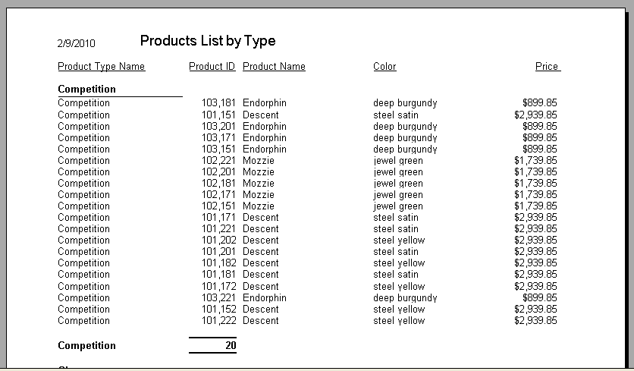
- Create the Employee List report based on the Oracle database HR. The report uses the information from the sample database to display the Employee List for HR with the fields shown from the employee and department tables. Grouped by the department name and sums the salary field for the group and grand total. Add a parameter screen that prompts for the department from a list of all department names. Add a second parameter for the Salary to show only salaries over the chosen amount entered.
